MESSAGE FROM THE ANWC PRESIDENT
August 14, 2019
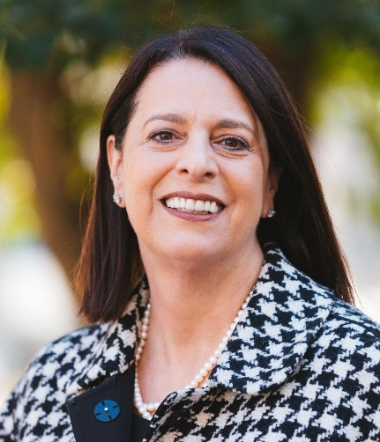

Dear Members and Friends of the ANWC,

I am pleased to welcome you to the 2019-2020 ANWC year and honored and proud to serve as the board president this year. In my view, at no time in American history has the news been more important. Over the next two years, I believe that the American New Women's Club has an important role in supporting those that educate and inform voters about our elections and critical issues facing our world.

Many of you don't know me, and what you should know is, at my core, I am a true bipartisan, who believes in comity, or why else would I have been an officer in the George W. Bush White House and served as the director of the George Soros Foundation in Macedonia? It is this balance that I like to bring to my life and want to bring to the ANWC.

By now, I hope that you have joined me in renewing your ANWC membership for the 2019-2020 year. You should have received your renewal package, but if you did not, please contact the Club office or click here for the renewal form. We are excited to have you continue as part of our historic club.

We already have booked fall activities in keeping with the theme of educating and informing about key issues facing our world:

The following club activities are in the works:

- Celebrating 100 years of the 19th Amendment: September 23, Sheilah Kast has secured Elaine Weiss, author of The Woman's Hour: The Great Fight to Win the Vote, and our board member, Eleanor Clift, author of Founding Sisters and the Nineteenth Amendment (Turning Points in History), for a celebration of the 19th Amendment.

- Women Ambassadors- Role of Women in Diplomacy: On October 24, Jan Du Plain amassing an impressive group of women ambassadors for a special program. Thank you to Sheilah and Jan.
- We are also working with the News Literacy Project on a program in November, setting a date for our holiday celebration, and more exciting programs in 2020.

- GALA MEETING: Please join us on September 4 for an open planning meeting for the 2020 Gala and Excellence in Journalist nominee. At this meeting, I hope we will have a meaningful discussion about potential EIJ nominees. I want to ensure that our 2020 EIJ recipient is culled from the best ideas from our membership, and I look forward to an invigorating discussion.

I am thrilled that you will be a part of our club and look forward to integrating your thoughts and ideas into our 2019-2020 agenda. Please reach out to me personally if you have ideas or concerns at President@ANWC.org, and I look forward to greeting you in person at one of our upcoming events.

Thank you for your support of the ANWC and your contributions to the role of the media in America. Please remember to check www.ANWC.org for updates, and we look forward to seeing you often this year.

With highest regards for your role in American media,
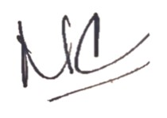
Mary Catherine Andrews

